Admin Interface Testing (ORACLE APEX)

Table of Content

1. Sign In

1. Admin sign in with empty username and password
2. Admin sign in with invalid password
3. Admin sign in with correct credentials

2. Trader

1. View basic detail of each trader
2. View Shop Details and products of each trader
3. View each trader dashboard
4. View daily report
5. View weekly finances
6. View monthly sales

3. Customer

1. View each customer details
2. View payment made by each customer
3. View reviews and ratings given by each customer

4. Dashboard

1. View Admin Dashboard

5. Logout

1. Admin is logged out of the admin page.

# Sign In

1. Admin sign in with empty username and password

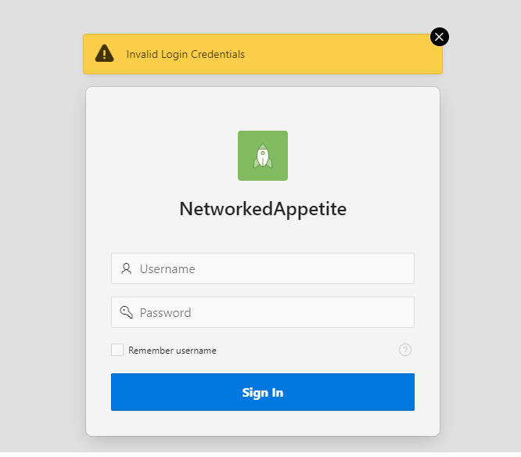

If admin tries to log in with empty username and password then an error message is displayed “Invalid Login Credentials”.

1. Admin Sign In With Invalid Password



If admin tries to log in with wrong password then an error message is displayed ’Invalid Login Credentials’

1. Admin login with valid credentials

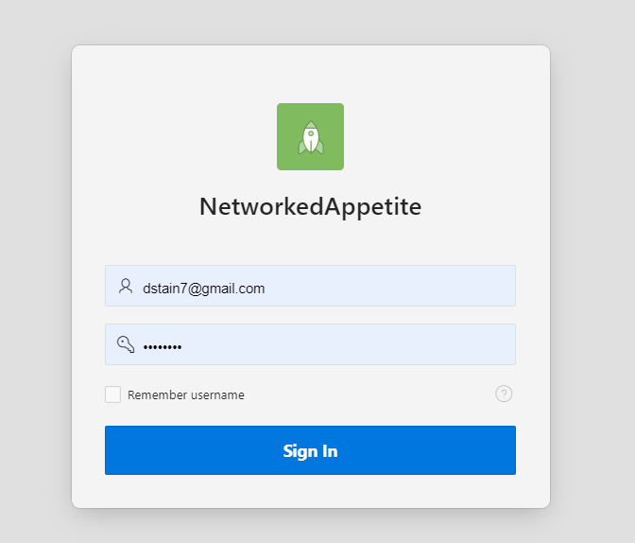

If admin log in with valid credentials then admin gains access to the admin homepage.

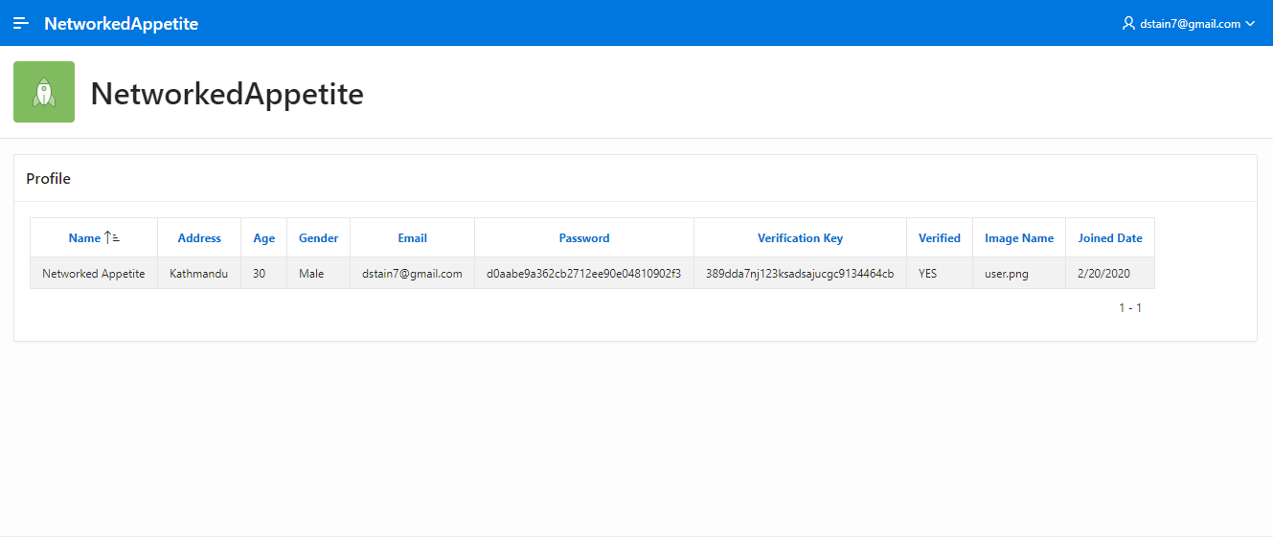

# Trader

1. View Basic Details of each trader

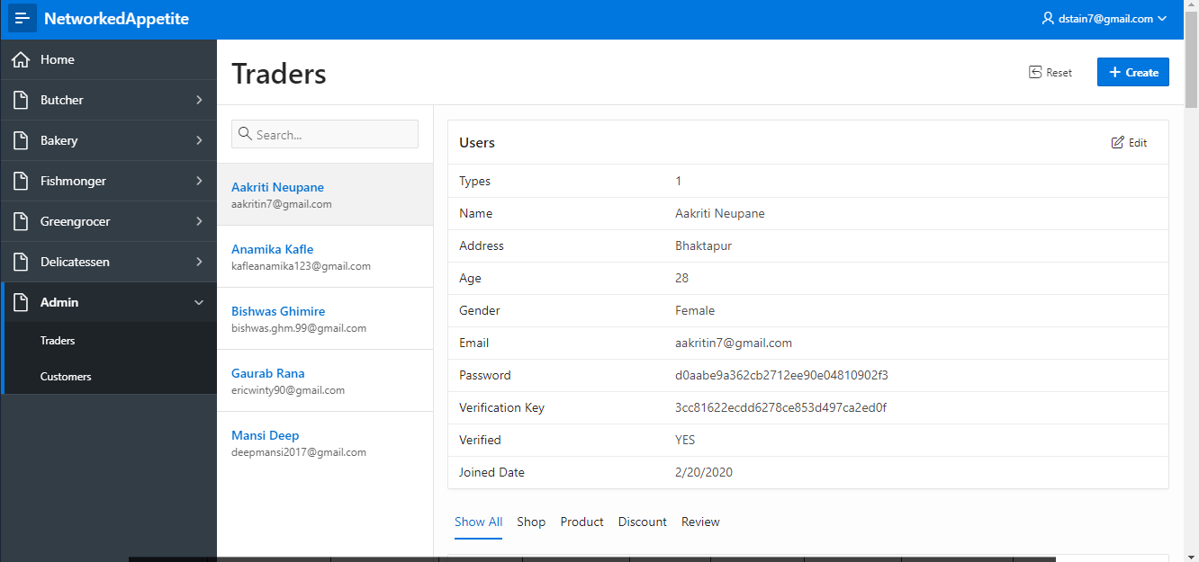

Admin can view details of each trader. Clicking on any trader name will give detail of their profile, shop detail, products sold, discounts given to product and reviews given to their products.

1. View Shop Type and Product sold by each trader

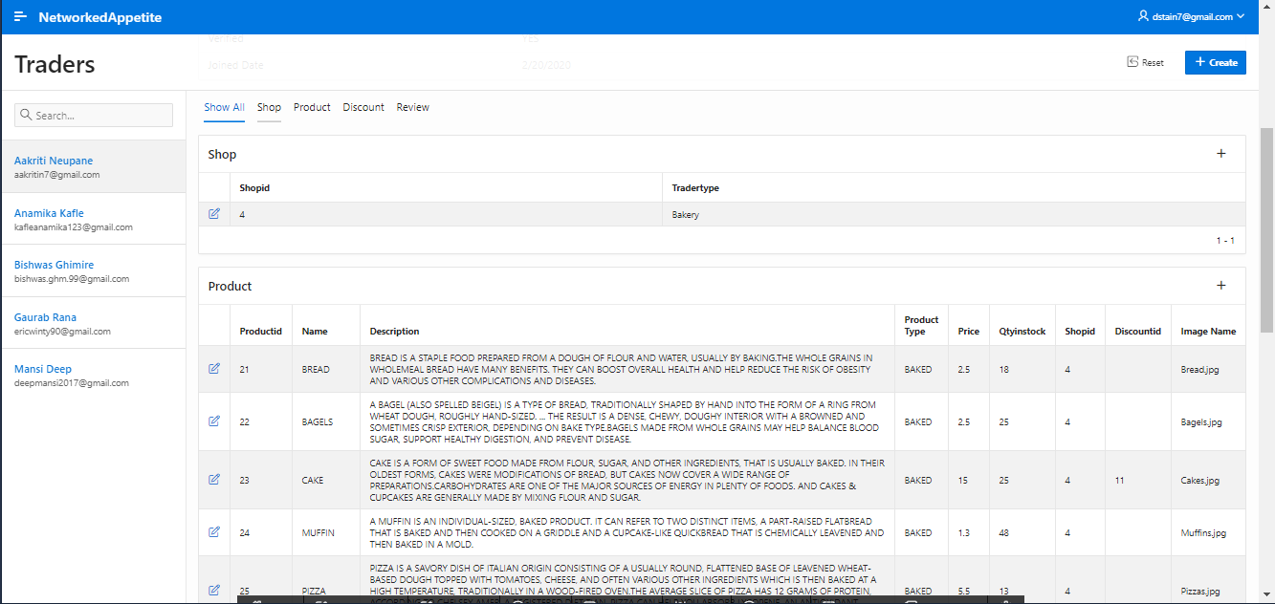

Admin can view detail of trader shop and products they sell.

1. View Dashboard

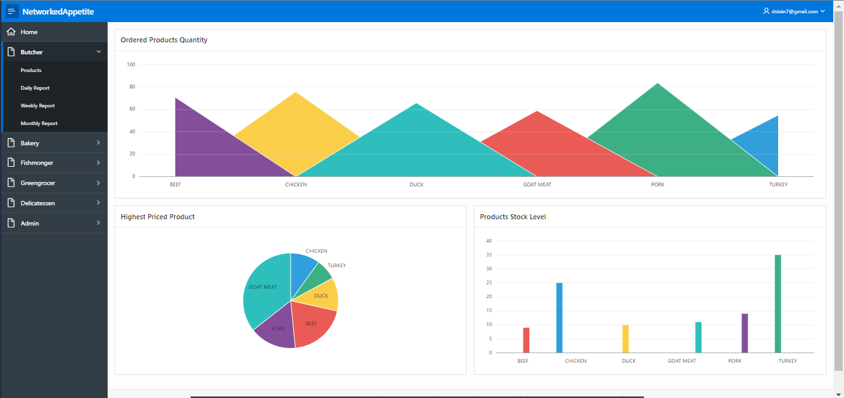

Admin can view dashboard of each trader. The first chart shows the most ordered product of the trader. Pie Chart shows Highest Priced Product and bar graph shows Product Stock Level.

1. View Daily Report

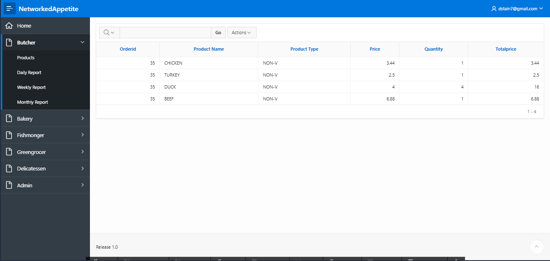

Admin can view Daily Report of each trader

1. View Weekly Finances

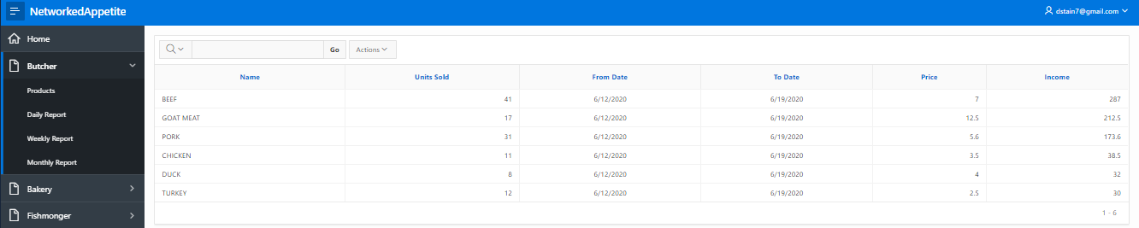

Admin can view weekly finance report of each trader

1. View Monthly Sales

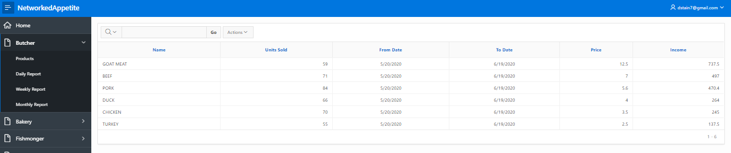

Admin can view monthly sales of each trader.

# Customer

1. View Customer Details

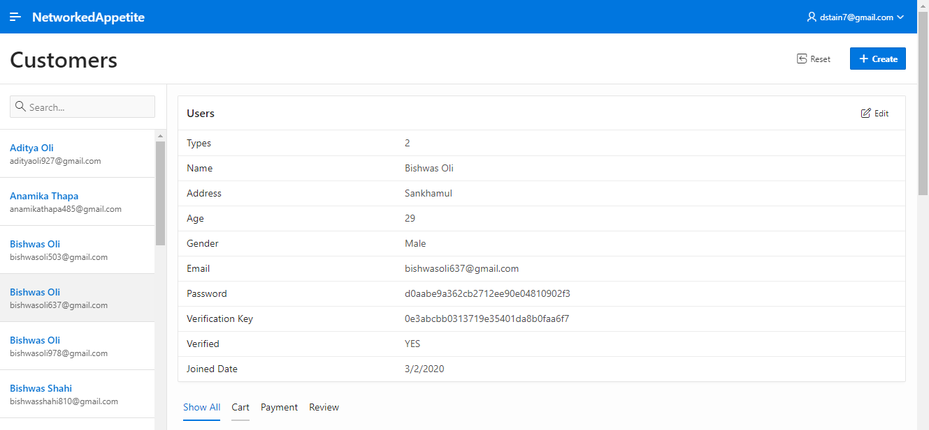

Admin can view all the details of each customer.

1. View Payment Made by Each Customer

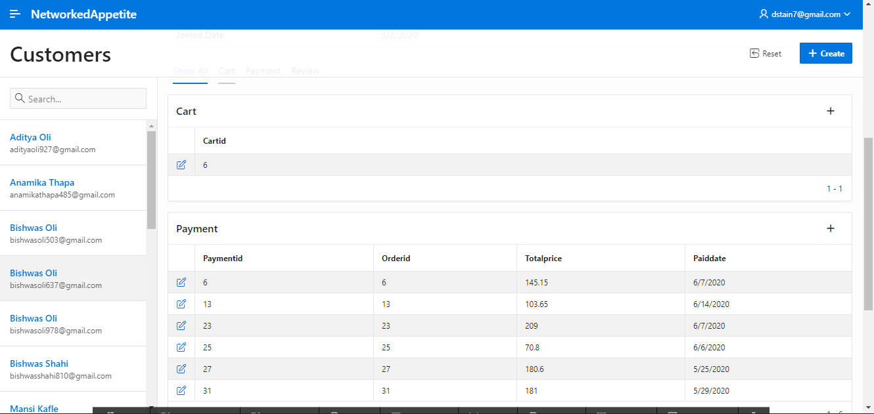

Admin can view all the payment details of each customer.

1. View Reviews And Rating Given By Customer

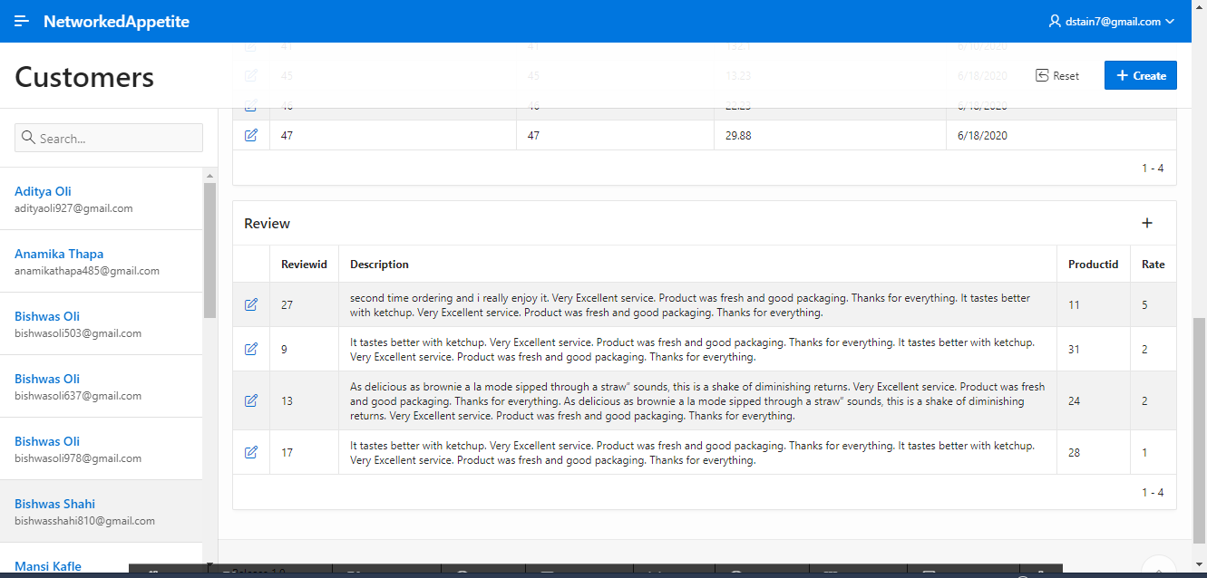

Admin can view all the reviews and ratings given by the customer.

# DASHBOARD

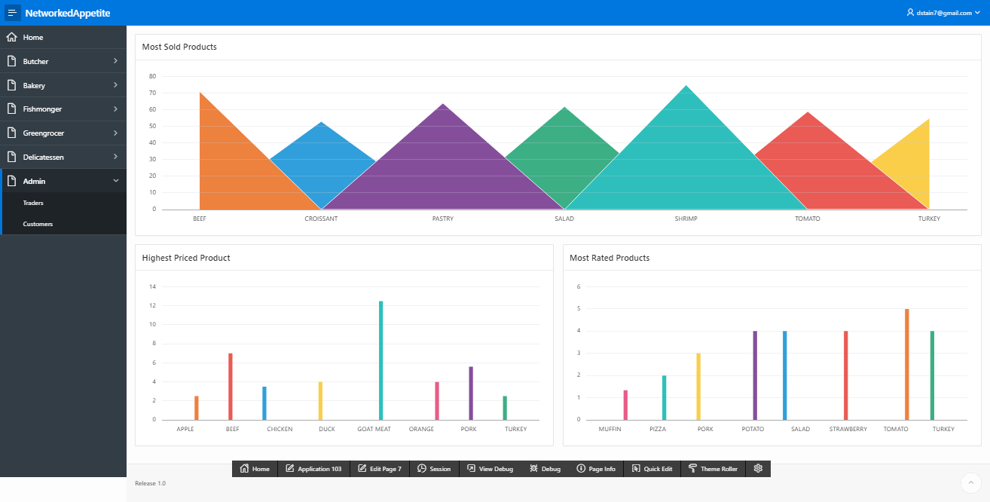

Admin also have access to overall dashboard where information like most sold product, most rated product, highest priced product are shown.

# Logout

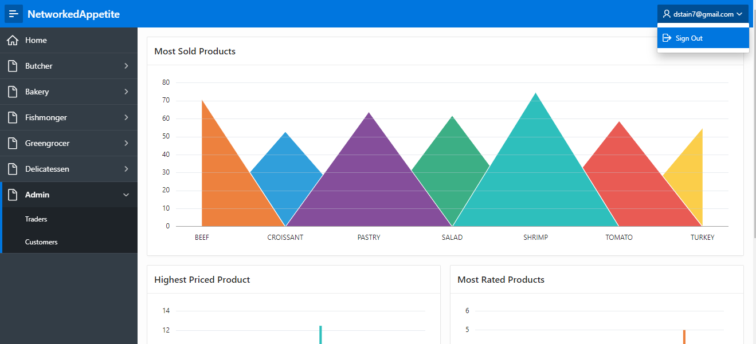

Admin can logout the dashboard from Sign Out button at the top right side of the page.